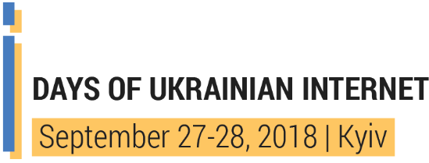 | IX UKRAINIAN INTERNET GOVERNANCE FORUM  KYIV, Sept 28, 2018,  UBI HALL (vul. Dorogozhitska 8)  http://igf-ua.org | 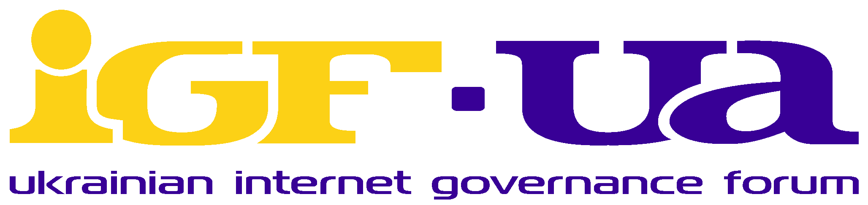
ORGANIZERS

 |  |  |  |  |  | 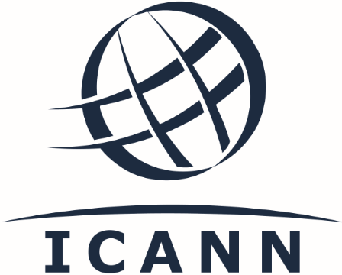
Ukrainian Internet Association (INAU) | Commission for Science and IT | RIPE Network Coordination Centre | ISOC (Internet Society) | IGF support association | NGO “Internews Ukraine” | Internet Corporation for Assigned Names and Numbers

SUPPORTED BY
Parliamentary Committee on Informatization and Communications of Ukraine | Cybercrime Programme Office (Council of Europe) | iNGO European Media Platform

MEDIASUPPORTING
Detector Media | Hromadske radio | DOU.UA | Zaborona | Internet.UA | Interfax-Ukraine

AGENDA
8:30 – 9:30 Registration (hall Fusion, 5nd floor), Coffee
09:30 – 10:50 | Forum opening, co-organizers welcoming words, hall Fusion, 5nd floor  Moderator: Olexandr Baranov, Head of Research Institute for Informatics & Law of National Academy of Legal Science of Ukraine  Plenary: FREEDOM AND SECURITY IN INTERNET  Moderator: Olexandr Fedienko, Head of InAU board  Speakers and experts:  - Olexandr Danchenko, Head of VR Committee on informatization and communicational  - Max Tuliev, Head of InAU Committee on human rights and freedom of speech  - Sergey Khariuk, PushRet  - Iryna Ckulivska, NGO “Digital Security Lab Ukraine”  - Viacheslav Marcinkovich, Cyberpolice Department of National Police of Ukraine
 | hall Fusion, 5nd floor | hall SHOW, 7nd floor
10:50 – 12:10 | Section №1.1: CYBERSECURITY  Moderator: Ivan Pietukhov, Vice-President of Ukrainian League of Industrialists and Entrepreneurs  Speakers:  - Ivan Pietukhov: “Using of tools of cyberincidents counteracting to influence on freedom of speech and human rights”  - Igor Kozachenko, cybersecurity expert: “Cyberprotection solutions in post-antivirus world”  - Oleg Gusiev, CA Commission on science and technology: “Legislative basis of cybersecurity: boon or destroying of Internet access market?”  - Kostyantyn Korsun, head of NGO Ukrainian Group of informational security: “Cybersecurity System of Ukraine: reality or myth?”  - Olexandr Fedienko, Head of InAU board, expert  - Giorgi JOKHADZE, Project manager Cybercrime Programme Office of Council of Europe: “Revised approach to cybercrime/security strategies”  - Markko Kunnapu (Estonia): “Discussion of the draft of Memorandum on cooperation”  - Uwe Rasmussen (Microsoft): “Liability of Internet Service Providers: confidentiality of users and protection of customers from online threats”  - Yuriy Tsyplynskyy, the State Service of Special Communication and Information Protection of Ukraine: “Ensuring of cyberprotection in Ukraine: responsibility of state and private sector”  - Mykhaylo Gutsalyuk, Interagency Research Center on Problems of Combating Organized Crime, National Security and Defense Council of Ukraine: “Regarding Memorandum on cybercrime counteraction between national cybersecurity subjects and ISPs”  - Alexandra Kulikova, ICANN: “ICANN mission on cyberawareness and in-process projects in this sphere”  - Safarov Farid Kamil oglu, Head of the Expert Group on the Digital Transport Infrastructure of the Directorate of the Ministry of Infrastructure of Ukraine  - Serhiy Sumsky, Department of Cyberpolicies of the National Police of Ukraine | Section №1.2: MEDIA IN THE AGE OF INTERNET  Panel discussion: This is not Wired. Who and how covers Internet and technologies in Ukraine?  Moderator: Vitalii Moroz, NGO “Internews Ukraine”  Is there any demand for quality journalism on technology and Internet, where has the money to come from?  Why there is no integrated statistics in media on Internet penetration in Ukraine?  Speakers:  - Dmytro Sizov, editor-in-chief of InternetUA.com  - Stanislav Yurasov, Liga Tech editor  - Andriy Brodetskyy, founder of Telegram channel “Technology, media and society”  Panel discussion: How is our understanding of media changing following development of Internet?  Moderator: Iryna Chulivska, NGO “Digital Security Lab Ukraine”  Who is more media: news web-site with one thousand of users or blogger with 100 thousand of followers?  What is the principal difference between on-line media and other informational resources (blogs, social-networks, so on)?  Do we need legislative definition of Internet media? Will it bring more benefits to journalists to protect their rights, or will it give more tools of influence on the content to regulators?  Speakers:  - Nina Kurjata, editor-in-chief of BBC Ukraine's (tbc)  - Kateryna Sergatskova, editor-in-chief of Zaborona  - Oksana Romaniuk, director of NGO Institute of Mass Information  - Olexandr Burmagin, director of NGO Human Rights Platform  - Kateryna Kobernik, deputy director of news department of 1+1, editor-in-chief of theBabel
12:10 – 12:40 Coffee (hall Fusion, 5nd floor)

 | hall Fusion, 5nd floor | hall SHOW, 7nd floor
12:40 – 14:00 | Section №2.1: CHILD ONLINE: SECURITY AND PROTECTION  Moderator: Olena Chernykh, Better Internet Centre  Experts:  - Victoriia Kosyk, State Scientific Institution «Institute of Education Content Modernization»: «Children online. Ukrainian reality»  - Richard Herts, UNICEF, «U-Report: Youth opinion on the Internet»  - Lubov Naidenova, head of the laboratory of mass communication psychology and media education of Institute of social and political psychology, NAES of Ukraine: «Rating of teenagers of online threats: mediapsycological recommendations»  - Elis Alexandrova, Nadiia Diatel, graduates of the Kyiv Junior Academy of Sciences: «Risks of self-harm behavior under the influence of the Internet»  - Olena Chernykh, Better Internet Centre: «Respect and security: monitoring of the websites of educational institutions and next steps»  - Markko Kunnapu (Estonia): «Fighting online abuse of children and the regulation of access to content in line with Council of Europe standards» | Section №2.2: DNS  Moderator: Svitlana Tkachenko, Communication Systems LTD  Section is devoted to recent advances in domain names governing, as well as new spheres of DNS application. Experts will tell about DNSSEC for Internet security, about WHOIS service, about problems and conflicts with using of domain names, and possible ways of dealing with these problems  Speakers:  - Alexandra Kulikova, Head of Global Stakeholder Engagement Eastern Europe and Central Asia, ICANN  - Kateryna Oliynyk, Law firm Arzinger  - Oleksiy Semenyaka, RIPE NCC  - Maxim Blagonravin, Hostmaster Ltd  - Yurii Kargapolov, INAU
14:00 – 15:20 | Section №3.1: PROTECTION OF INTELLECTUAL PROPERTY RIGHTS IN DIGITAL SPACE  Moderator: Yurii Kargapolov, INAU  Speakers:  - Konstantyn Zerov, chair of intellectual property rights at Kyiv National University  - Yuriy Goncharuk, Ukrainian Network Informational Center  - Oleksiy Krasovskiy, Yuskutum  - Kateryna Oliynyk, Law firm Arzinger  - Kateryna Fiodorova, Clear Sky Initiative | Section №3.2: UKRAINE AND REFORM OF EUROPEAN LEGISLATION ON ELECTRONIC COMMUNICATIONS  Moderator: Oksana Prykhodko, iNGO European Media Platform  Speakers:  - Andriy Birukov, Coordination Council at Cabinet of Ministers of Ukraine on development of digital economy and society  - Yuliya Gariacha, Governmental office of European and Euro-atlantic integration  - Liliya Oleksiuk, Coordinator of Ukrainian side of Civic Society Platform of EU-Ukraine Agreement on Association  - Giorgi JOKHADZE, Project manager of Cybercrime Programme Office of Council of Europe  - Alexandra Kulikova, Head of Global Stakeholder Engagement Eastern Europe and Central Asia, ICANN
15:20 – 15:50 Coffee (hall Fusion, 5nd floor)

 | hall Fusion, 5nd floor | hall SHOW, 7nd floor
15:50 – 17:10 | Section №4.1: RISKS OF CURRENT SITUATION ON INTERNET-MARKET  Moderators: Yurii Kargapolov, INAU, Olexandr Baranov, Head of Research Institute for Informatics & Law of National Academy of Legal Science of Ukraine  Speakers:  - Farid Nakhli, ITU, program coordinator  - Olexandr Arutiunian, Head of InAU Committee on protection of business competitions  - Maxim Smolianets, investor of You TV projects  - Roman Perun, Prime-net | Section №4.2: DIGITAL RIGHTS PROTECTION  Moderator: Vitalii Moroz, NGO “Internews Ukraine”  Workshop on Internet and freedom of speech in European context. How can we understand regulation and censorship: challenges and trends?  Why on-line space is becoming key ring in XXI century? How does state regulation work and how do they threaten users rights and freedom of speech? European lessons for Ukraine  Speaker: Antonina Cherevko, medialawyer, International Media Support (IMS)  Panel discussion: How to protect right on free Internet in Ukraine? Perspectives for 2019-2020  Only three years ago it was difficult to forecast the necessity to protect free Internet from over-regulation. Why did the regulation of Internet begin only on the third year of war and why it does not work? Can IT-community, civic society and pro-European politicians protect free Internet in nearest future?  Speakers:  - Maxym Dvorovyy, lawyer, CEDEM  - Oksana Maksymenyuk, lawyer, IRPD  - Pavlo Moiseev, Legal Director, Internews Ukraine  - Iryna Chulivska, NGO “Digital Security Lab Ukraine”  - Maxym Tuliev, InAU
17:10 – 18:30 | Plenary: EVOLUTION OF INTERNET GOVERNANCE SYSTEM (hall Fusion, 5nd floor)  Moderators: Oksana Prykhodko, iNGO European Media Platform, Oleksiy Semenyaka, RIPE NCC  Speakers:  - Yuriy Kargapolov, INAU  - Alexandra Kulikova, ICANN  - Volodymyr Nochvai, head of Ukrainian side of Civic Society Platform of EU-Ukraine project  SUMMARY  Moderator: Olexandr Baranov, Head of Research Institute for Informatics & Law of National Academy of Legal Science of Ukraine  Messages from all sections  Final remarks of co-organizers.
18:30 | Informal communication (hall Fusion, 5nd floor)

